1-)Adding A New Customer
We asked for user ID name, last name, sex and credit. Then we created a new object.
We created an arraylist in the customer type. This arraylist name is bank.
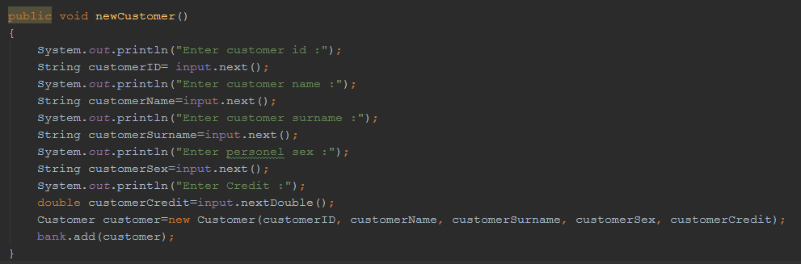
2-)Deleting The Customer
User enter id after find the customer arraylist. Then control the id in arraylist after that delete the information, increase the size. 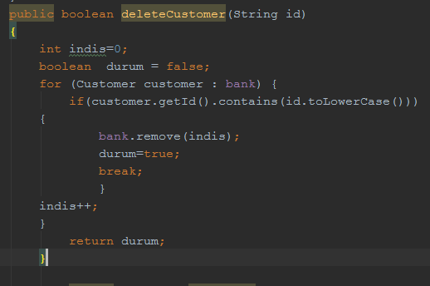
3-)Listing All Customers
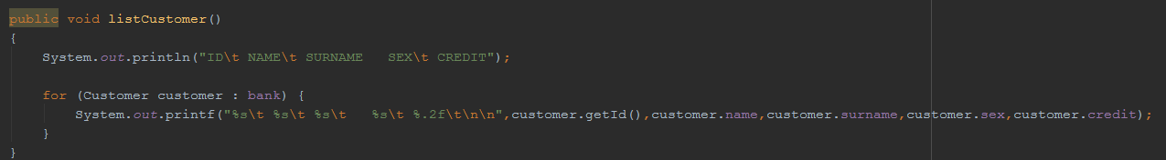
We print the array list from the customer arraylist to the screen.
4) Listing Customers by Customer ID
Assign a variable in the customer type. This variable is null. Then user enter id, we bring the information that customer type of arraylist. After that return customer.
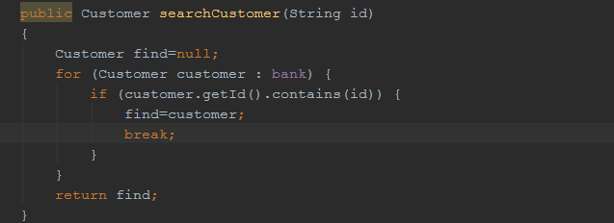

5)Update
We wanted the information from the user. A method that takes a variable from the customer arraylist. We are writing directly on the information in arraylist.
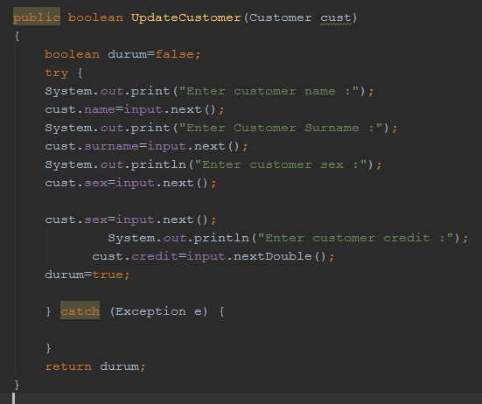

6)Adding Credit
We define variable of customer type. If user id match the id in arraylist, get the information on arraylist. After that, adding credit the customers arraylist. 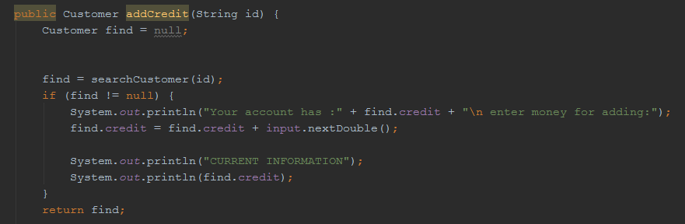

7)Draw Credit
We define variable of customer type. If user id match the id in arraylist, then control the new credit grader than previous credit. Get the information on arraylist. After that subtract credit the customers arraylist.
